Communication Group Planning Week commencing:

Group Learning Outcomes: I am learning to use body language, gestures and facial expressions to communicate Critical priorities. | Individual learning outcomes for children:  - To join group by sitting on a chair (for 1 minute)  - To make a choice (from a toy bag) ‘I can request by reaching’  - To take turns in a group activity with adult support.  - To socially interact with others.  - To recognise name and picture.  - To develop joint attention with others – Dough disco, parachute games etc. Linked to physical development and AOP planning.  - Link with singing and rhyming – use of claves | Children in group: | Staff:
Session Plan:
Children sat in circle on chairs:  Hello Song using the general nursery hello song for a different approach. Use Makaton signing for the words (hello, good, you, here)  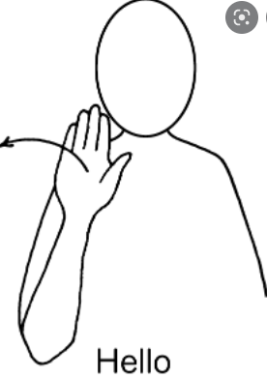– 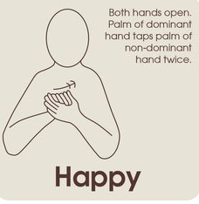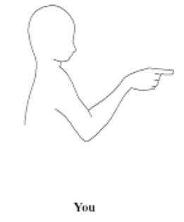  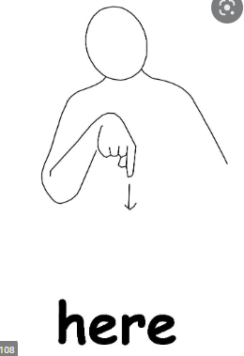  Using mirror, led by teacher or TA. Take turns welcoming each child in group shaking hands and looking at themselves in the mirror.  Child looks for their picture on the folder and places it on the other side.  Show visual for activity – on clipboard – choose activity  Changing the activity within group.  What’s in the Bag – with animals  Making animal noises.  Sensory balls  Musical instruments  Feathers  Show visual for toys.  Child gets the opportunity to choose toy from the sack.  Song when they have made their choice of toy.  (Choose a toy that you can play with, you can play with, you can play with…keep to singing once to add pace to session )  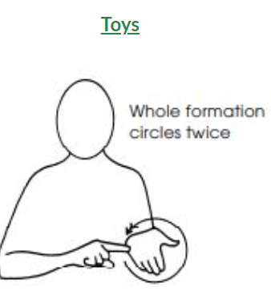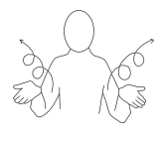  Allow child to play with choice of toy.  (Child chose the …to play with)  Selection of Nursery Rhymes/Songs for the children to choose from on a sentence strip.  Also only one person give instructions.  Reinforce: Good sitting/good choosing try to use sign so that children learn sign for these instructions.  Time to put the toys away song. Put the toys into the sack.  Game to end session: Shake the bed/Parachute game/Wiggle song/foil blanket with water sprayed on/ parachute with balloons/feathers on for shaking up and down.  Goodbye song to dismiss children. Use the general nursery song for good bye song using the Makaton signing then saying child’s name. | Notes/Observations: Monday
 | Notes/Observations: Tuesday
 | Notes/Observations: Wednesday
 | Notes/Observations: Thursday
 | Notes/Observations: Friday
Resources: | Folder with name/picture cards  Visual for toys  Soft mirror  Chairs in circle  Cause and effect toys in bag (new fidget toys)  Tin Foil Sheet (can add a little bit of water to create sprinkles.)  Parachute (could use a cuddly toy to bounce in the air)  Lycra  Wiggle

