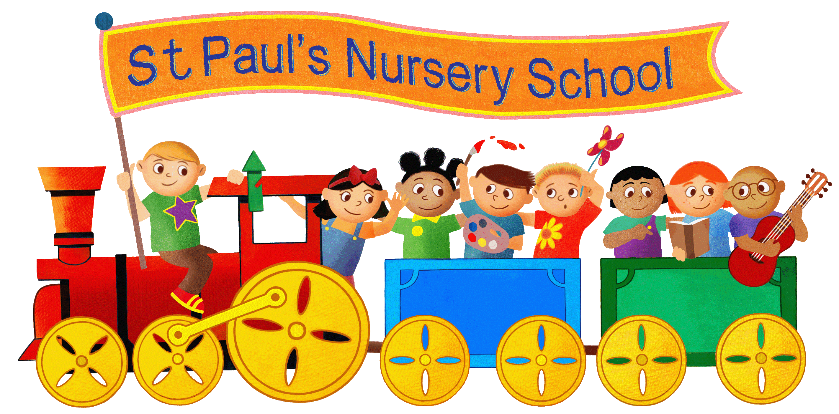

Policy for admissions
and transition

The Governing Body of St. Paul's Nursery School
endeavours to write and adopt policies that are fully inclusive for all children / staff / parents / carers /
governors and members of the wider community.

Policy approved by Governors: Oct 2023

Signature of Chair of Governors: S McGrellis

Date for renewal: Oct 2024
Updated April 2025

“St Paul’s is not a school, it is a family.”
All are Welcome
At St Paul’s Nursery School we strive to be a setting where children are nurtured and educated to become independent, confident and have the skills needed to continue to grow and develop.
We aim to be:
- A place where all are welcome and individual talents are explored and steps of progress no matter how small are celebrated.
- A place where we work with families to support and guide children in their most important early years.
- A place where staff are dedicated to their children and through their own professional development ensure everyday, every play and in every way children thrive.
We will do this by;
- Putting the children at the heart of everything we do.
- Providing a setting where children are seen as individuals, where their needs are identified and responded to and where they are given the best possible chance to fulfil their talents.
- Encouraging children to grow in confidence and self-esteem, to become more independent and learn to take responsibility.
- Encouraging curiosity, creative thinking and questioning minds.
- Creating a happy, safe, secure and stimulating environment.
- Working together as a mutually supportive, creative and innovative team.
- Supporting parents and carers in their role as educator and value their contribution.
- Respecting ourselves, each other and our world.

Rationale
We believe that all children should feel as comfortable, confident and emotionally secure as possible when entering the nursery. They need to feel that they are a valuable, competent member of the new social group, and they need to develop positive attitudes towards the range of new experiences they will encounter. During any transition period children need to be helped to retain the self confidence and self-respect that they have already gained at home or in previous settings. We understand that children enter nursery from a variety of backgrounds and will respond to it in many different ways. We therefore aim to welcome all children as individuals and will meet their needs accordingly.
Getting to know a child and planning for admission to the setting require parents / carers and practitioners to engage in an equal partnership in which both learn from each other.

Admissions
- Prospective parents are welcome to visit the nursery and are encouraged to bring their child with them.
- Children’s names can be put on the waiting list once they are 1 year old.
- Children are allocated a place when there is space or they turn 2 years old. Entry points generally are September, January and after the Easter holiday.
- Children can start mid term if needed.
- Children can start once they are 2.
- Places are given on a first come first served basis upon receipt of their application form.
- Within 1 month parents will be advised whether the spaces they are requesting are available.
- Parents are sent a letter offering their child a place along with a booklet about the nursery and key policies they must read and agree to.
- When the place is accepted the child and parents/carers are invited to two short taster sessions during nursery time so they can see the nursery school in action. Parents fill in necessary paper work and are given information about how the nursery school operates.
- Each child is assigned to a key person who is responsible for their pastoral care.
- Children are allocated a starting date. These are staggered where possible to ensure that the staff are on hand to help to settle a few children into nursery at a time. On the first day we ask parents and carers to bring their child for part of the session and to stay with them. On the second session children can be left.
- Parents are encouraged to say hello to their key person on a daily basis and to discuss children’s needs.

Oversubscription
- If an application form is received and we do not have spaces available for all sessions requested an offer will be made for the available spaces and the child will be put on the waiting list for the others.
- Parents then have the opportunity to accept or reject the offer.
- Parents are then notified when the space becomes available.

Transition to school
- Liaison takes place throughout the year with our main receiving schools through the Shared Foundation Partnership groups. Teachers arrange to visit nursery to see children in situ and children are invited to attend primary school taster sessions.
- Children in the enhanced resource centre are accompanied if possible on at least one of their taster sessions in school. Liaison meetings between nursery, outside agencies and schools take place as soon as we know definitely to which school a child is going to transfer.
- Children’s reports and assessments are sent home to parents.
- Assessment details are also shared with receiving schools.

