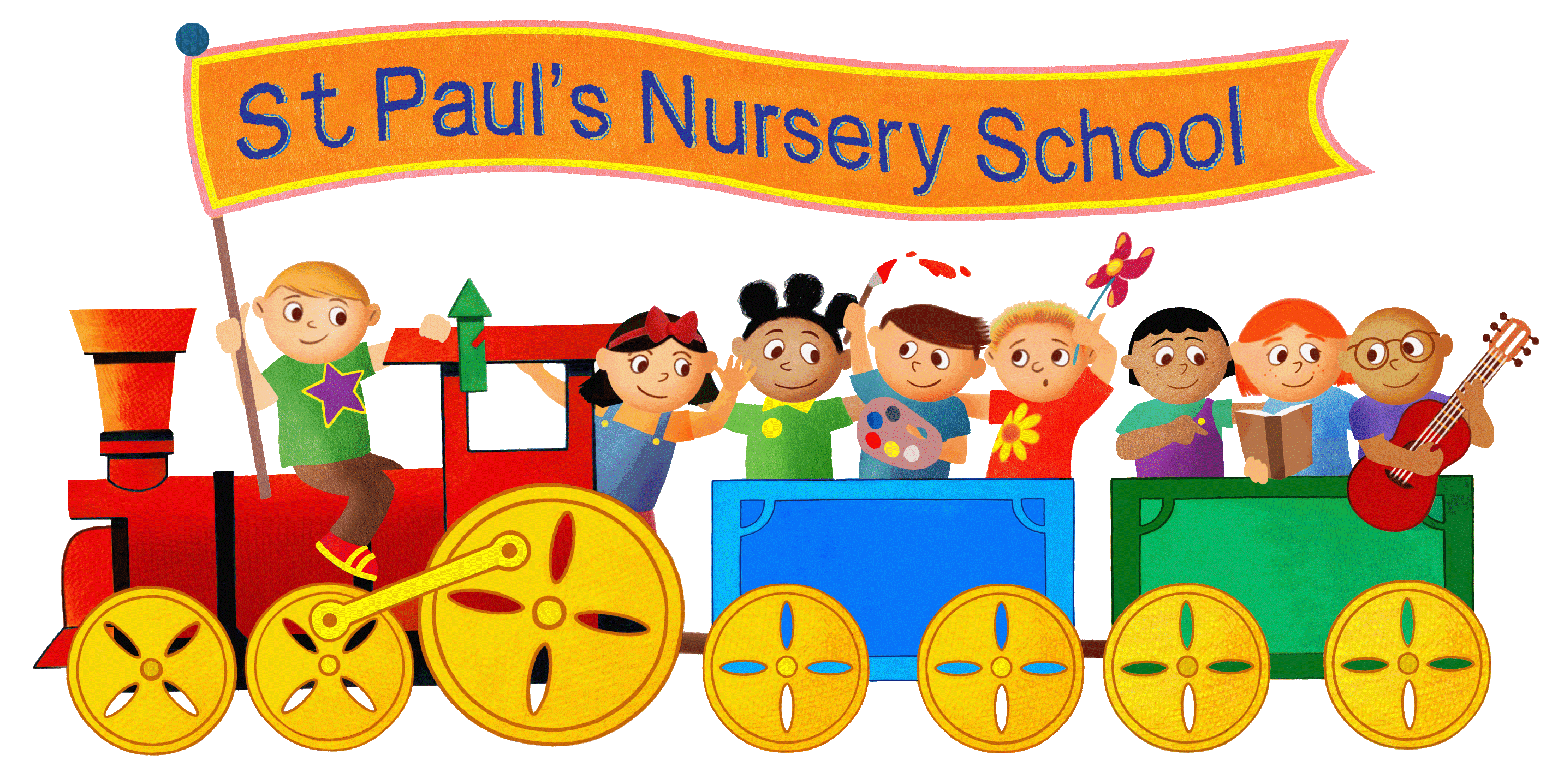
Application form

Tel: (01904) 555995
E-mail: st.pauls.nursery@york.gov.uk
www.stpaulsnurseryschool.co.uk
Head teacher: Mrs Claire Rigden

Child’s details
Full name of child:

Name child is known as (will be on their name card):

Desired start date (child must be 2years 6 months old):
Gender: Male Female | Preferred pronouns: he/him she/her they/them
Child’s address: | Child’s DOB:
 | Birth certificate seen: Y/N (admin use only)
Allergies: (eg, plasters, foods, drinks etc) | Medical conditions:
Dietary requirements: | Ethnic origin:
First language: | Religion:
Is there anything else we need to know about your child?

Are there any other professionals involved with your child? For example, social care, speech and language, paeatrician…
Names of any siblings that attend / have attended St. Paul’s Nursery School:

Parent’s details
Parent/carer 1 Name:  Parental responsibility Y/N | Parent/carer 2 Name:  Parental responsibility Y/N
Preferred pronouns: he/him she/her they/them | Preferred pronouns: he/him she/her they/them
Address: | Address:
DOB:  National Insurance No: | DOB:  National Insurance No:
Email address: | Email address:
Home phone number: | Home phone number:
Mobile phone number: | Mobile phone number:
Work phone number: | Work phone number:

Emergency contact details
Please provide details of 2 adults (must be over 16), other than parents, who we may call in the event of an accident or emergency.
Name: | Name:
DOB: | DOB:
Home phone number: | Home phone number:
Mobile phone number: | Mobile phone number:
Relationship to child:(eg, relative, friend) | Relationship to child:(eg, relative, friend)
Permission to regularly collect:  Yes no | Permission to regularly collect:  Yes no

Attendance pattern

Your child can attend nursery at any given days and times that suit your needs (subject to availability). Please indicate below what sessions you would like to request. Working parents can also apply to access 30 hours of funded places. This will be taken into account when calculating a monthly fee payable to the nursery. For more information on 15/30 hours funding, to apply please visit www.childcarechoices.co.uk

Please note that if you are eligible for and have received notification confirming 30 free funded hours from HMRC and passed this to nursery, you can use them to include breakfast and after school club. For example a 30 hour place would cover 7:30 – 6 Monday, Tuesday and Wednesday. Any other hours can be purchased at the prices listed below. Please make sure that you apply for the funded hours before the deadline for each term: 31st August for the Autumn term, 31st December for the Spring term and 31st March for the Summer term.

Lunch is provided by an outside caterer at a cost of £3.00 per day which cannot be included in your 30 hour entitlement.
 | Breakfast club | Morning | Lunch time | Afternoon | After School provision | Full day place 7:30 – 6
 | 7:30 – 8:30  £3.50 | 8:30 – 11:30  £15 | £3.00 meal  £4.00charge for care. | 12:30 – 3:30  £15 | 3:30 – 6  £10.50 | £48.00 including meals
Monday
Tuesday
Wednesday
Thursday
Friday
At St Paul’s Nursery School we pride ourselves on offering the highest quality education that we can. This isn’t possible with the funding allocated through the two, three and four year old scheme. In accordance with their terms and conditions we do not charge for care, however we do charge an additional facilities fee that covers snacks, drinks, breakfast, tea, activities, use of the square garden for forest schools, sun cream and other high quality resources such as visitors like professional storytellers and other curriculum enrichment opportunities we offer.

This fee is worked out as an additional £1 per hour for funded sessions. This is then multiplied by 38 weeks and divided by 11 months to give you monthly fee.
All fees are broken down and itemised on invoices given to you at the start of your child’s place.

We offer a 50% discount on the ‘additional facilities’ fee to any families who were eligible for the early years pupil premium and also a 15% sibling discount for two siblings attending at the same time. Please let our team know if you are eligible for the funding.

How did you hear about us? ________________________________________________________

Please indicate how you intend to pay your fees: please circle all that apply

Childcare vouchers Direct with the Famly app Tax Free Childcare Account

Please note that we are a cash free school and all fees must be paid online. We do our best to allocate families their first choice of place although this is not possible in all cases. We follow local authority guidance regarding admissions in order to ensure a fair and consistent approach is used. Please let us know if your preference changes, if you no longer require a place, or if your contact details alter. We review our prices annually and they are subject to change.
What happens next?

Within 20 working days we will send you an offer letter/email outlining the places we have available if your start date is within 6 months. If longer we will acknowledge your application and then contact you within 6 months of starting with an offer. If you wish to accept the place a non refundable administration fee of £50 can then be paid online and the £50 will be put towards your first invoice.

